http://www-h.eng.cam.ac.uk/help/programs/fe/abaqus/faq68/abaqusf2.html

<https://info.simuleon.com/blog/how-to-submit-and-monitor-abaqus-jobs-through-command-window>

<https://lunarc-documentation.readthedocs.io/en/latest/Abaqus/>

<http://home.iitk.ac.in/~saiwal/computing/useful-commandstips-for-using-abaqus-over-command-line-in-linux/>

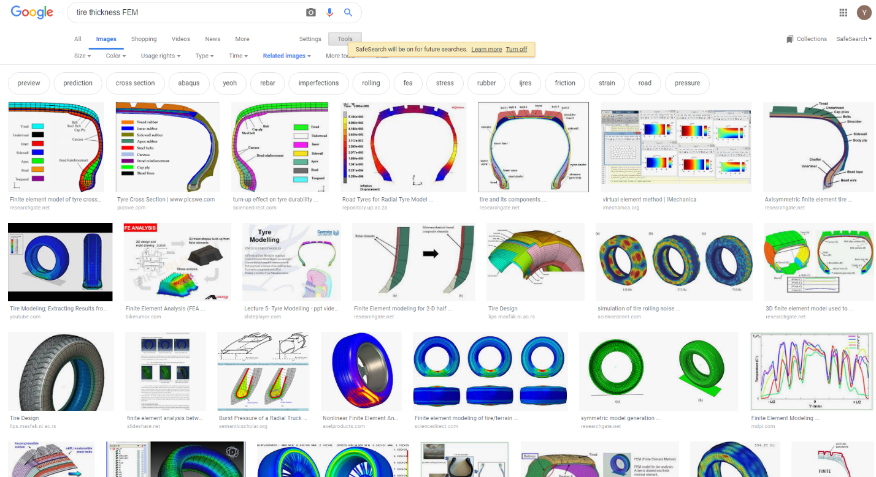

In google. Search for

Tire CAD models 215/55R16 architecture

Tire CAD truck tire R24.5 architecture

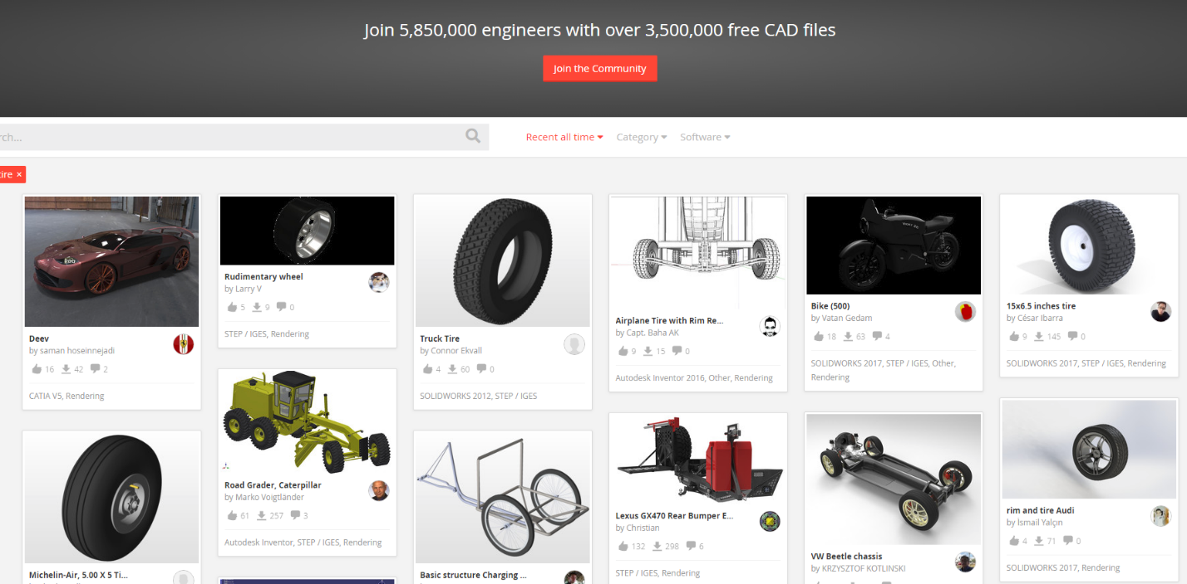

How to work with .inp files:

**Youtube.com**

<https://www.youtube.com/watch?v=GJNcyyVQcH4>

<https://www.youtube.com/watch?v=arhlypzX-QQ>

<https://www.youtube.com/watch?v=Z5XQ38YfHxg>

**How to work with orphan mesh:**

<https://www.researchgate.net/post/How_can_I_convert_orphan_mesh_to_geometric_mesh_in_abaqus_or_make_a_geometric_part_of_orphan_mesh>

**What is ABAQUS part**

<https://abaqus-docs.mit.edu/2017/English/SIMACAECAERefMap/simacae-c-asmconcinstancesrelationship.htm>

**What output variables are there:**

https://abaqus-docs.mit.edu/2017/English/SIMACAEOUTRefMap/simaout-c-stdoutputvar.htm

**How to work with ABAQUS odb files:**

<https://www.youtube.com/watch?v=dHsN6wByW3g>

<https://www.youtube.com/watch?v=Ti17PMxHKGo>

**How to work with “create display group” in ABAQUS**

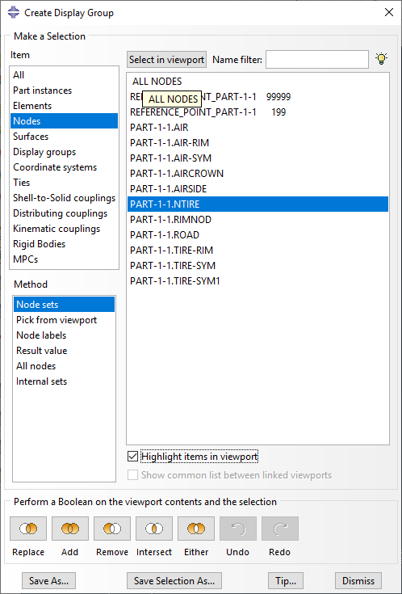

[**https://abaqus-docs.mit.edu/2017/English/SIMACAECAERefMap/simacae-t-dgphlpcreate.htm**](https://abaqus-docs.mit.edu/2017/English/SIMACAECAERefMap/simacae-t-dgphlpcreate.htm)

[**https://www.youtube.com/watch?v=MpUwi5_wrbM**](https://www.youtube.com/watch?v=MpUwi5_wrbM)

[**https://www.youtube.com/watch?v=7e0HhzhfL-I**](https://www.youtube.com/watch?v=7e0HhzhfL-I)